**Alenne Jasper Cañete**

**BSIT – 3rd Year**

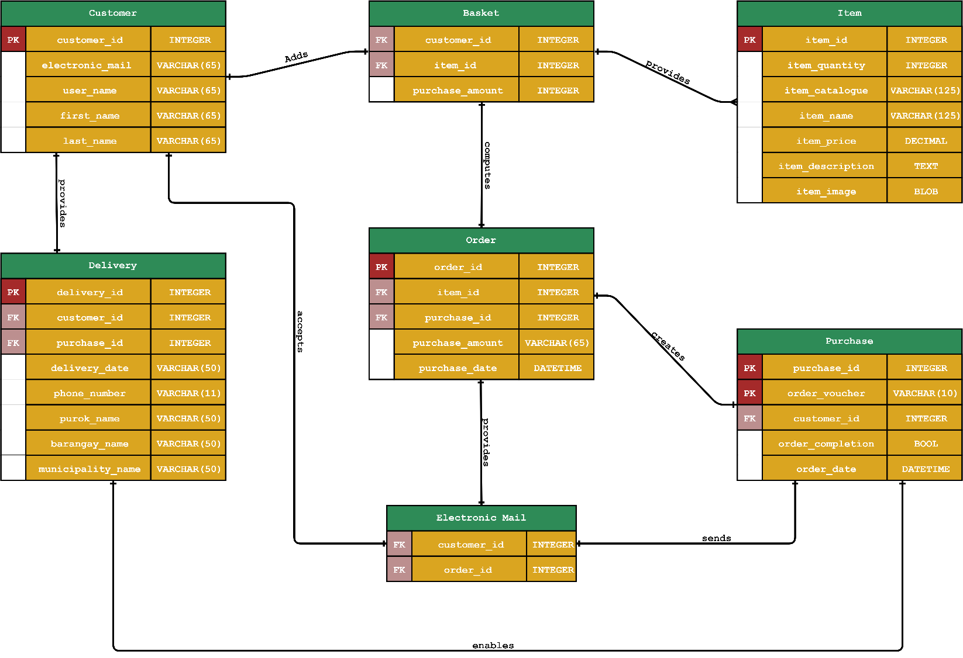

**E–commerce Information System**

**Entity – Relationship Diagram**